**Description**

As a user I must have ability to view all the menu categories

As a user I must have ability to view each menu category.

------------------------------------------------------------------------------------------------------------------------------------------

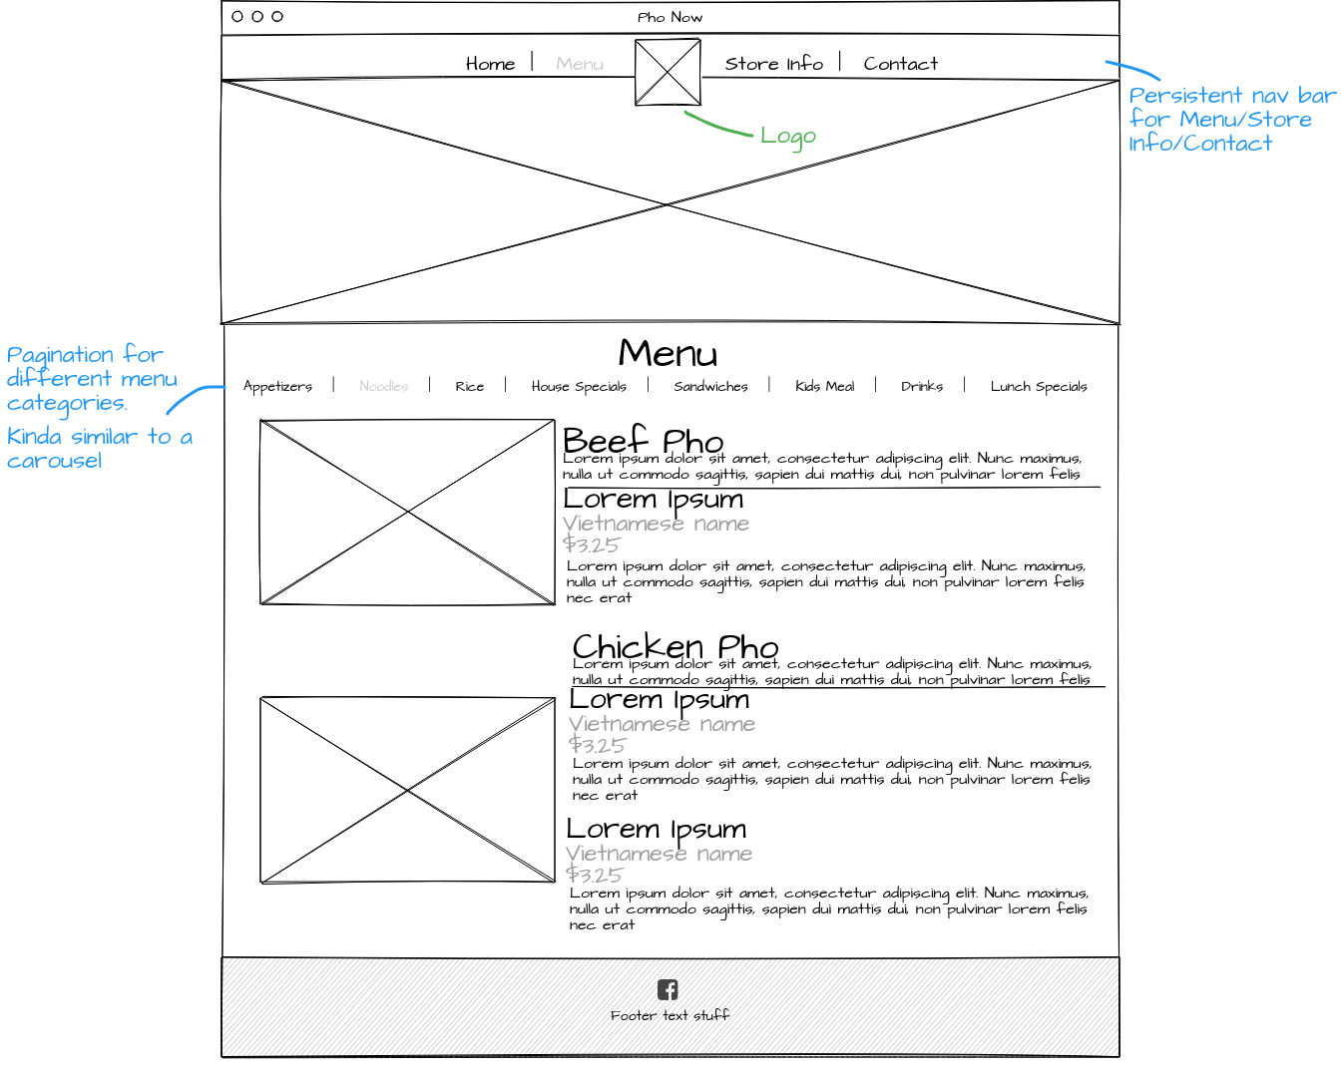

**Acceptance criteria**

* Display all the menu items from the menu category with following details
  + Menu item name in English
  + Menu item name in Vietnamese
  + Menu item brief description
  + Menu item price
* Display 5 items per page. Use pagination if menu category has more than 5 items
* Display Submit button .
* Display message from owner.